
FIREWALL-DoS TRAFFIC CONTROL AND UNAUTHORIZED ACCESS

A Project Report submitted to
MOHAN BABU UNIVERSITY

in Partial Fulfillment of the Requirements for the Award of the degree of
BACHELOR OF TECHNOLOGY IN

COMPUTER SCIENCE AND ENGINEERING (CYBER SECURITY)

Submitted by
YELLAMARAJU SONALI | (24102A020082)
SALAPADI RAAHITYA | (24102A020065)
NALLALA VEERABABU | (24102A020053)

Under the Guidance of
Dr. V. Jyothsna
Deputy Dean (Academic Affairs)
Assistant Professor
Department of Data Science


Department of Data Science
SCHOOL OF COMPUTING
MOHAN BABU UNIVERSITY
Sree Sainath Nagar, Tirupati – 517 102, A.P., INDIA
2026-27
MOHAN BABU UNIVERSITY
Sree Sainath Nagar, Tirupati – 517 102, A.P., INDIA
2026-27
DEPARTMENT OF DATA SCIENCE

CERTIFICATE
This is to certify that the project report entitled
“FIREWALL-DoS TRAFFIC CONTROL AND UNAUTHORIZED ACCESS”
is the Bonafide work done by following students.
Submitted by
YELLAMARAJU SONALI | (24102A020082)
SALAPADI RAAHITYA | (24102A020065)
NALLALA VEERABABU | (24102A020053)
in the Department of Data Science, and submitted to Mohan Babu University, Tirupati in partial fulfillment of the requirements for the award of the degree of Bachelor of Technology in Computer Science and Engineering (Cyber Security) during the academic year 2026-2027. This work has been carried out under my supervision. The results of this mini project work have not been submitted to any university for the award of any degree or diploma.
Guide: Head:
Dr. V. JYOTHSNA Dr. K. Reddy Madhavi
Deputy Dean (Academic Affairs) Professor and Head
Assistant Professor Dept of Data Science
Dept. of Data Science

DECLARATION

We hereby declare that this project report titled “FIREWALL-DoS TRAFFIC CONTROL AND UNAUTHORIZED ACCESS” is a genuine work carried out by us, in BTech (Computer Science and Engineering (Cyber Security)) degree course of Mohan Babu University, Tirupati and has not been submitted to any other course or University for the award of any degree by us.
We declare that this written submission represents our ideas in our own words and where others' ideas or words have been included, we have adequately cited and referenced the original sources. We also declare that we have adhered to all principles of academic honesty and integrity and have not misrepresented or fabricated or falsified any idea / data / fact / source in our submission. We understand that any violation of the above will cause for disciplinary action by the Institute and can also evoke penal action from the sources which have thus not been properly cited or from whom proper permission has not been taken when needed.

Signature of students
1.
2.
3.

ABSTRACT

The Firewall Implementation project focuses on using a firewall to control and protect network communication between a computer system and external networks. A firewall filters incoming and outgoing network traffic based on conditions such as IP addresses, protocols, ports, applications, and services, allowing permitted traffic and blocking unauthorized or unwanted connections.

In this project, firewall rules are configured to control network traffic, including the selection of inbound or outbound rules, protocols and ports, network profiles, and allow or block actions. The configured rules are then tested to verify whether the expected connections are permitted or blocked. Firewall logging can also be used to record successful connections and dropped packets for monitoring and verification.

The project demonstrates that a properly configured firewall provides an important layer of network security by reducing the attack surface and restricting unauthorized traffic. It also shows the importance of correct rule configuration, testing, and regular management for maintaining effective protection.
Furthermore, the project highlights the importance of monitoring firewall activity and verifying the results after applying security rules. Testing helps identify whether the configured rules behave as expected and whether legitimate network communication continues without unnecessary interruption. Regular review and maintenance of firewall settings can improve the effectiveness of network protection.
Overall, this project provides a basic understanding of firewall configuration, network traffic filtering, and security rule management. It also emphasizes that a firewall should be combined with other security measures to provide stronger protection against different types of cyber threats.
Keywords: Firewall, Network Security, Firewall Rules, Network Traffic, Unauthorized Access, Traffic Filtering, Security Monitoring.

TABLE OF CONTENTS
Title Page No
CHAPTER-1: INTRODUCTION 8
CHAPTER 2: PROBLEM STATEMENT 9
CHAPTER 3: AIM AND OBJECTIVE 10
CHAPTER 4: FIREWALL BASICS 11
CHAPTER 5: TYPES OF FIREWALLS 12-14
CHAPTER 6: FIREWALL AND RELATED ATTACKS 15-16
CHAPTER 7: DoS ATTACK 17-18
CHAPTER 8: UNAUTHORIZED ACCESS 19-20
CHAPTER 9: TOOLS REQUIRED 21
CHAPTER 10: SYSTEM ARCHITECTURE AND WORKING 22-24
CHAPTER 11: IMPLEMENTATION PROCEDURE 25-28
CHAPTER 12: FIREWALL RULES AND TESTING 29-30
CHAPTER 13: RESULTS AND DISCUSSION 31
CHAPTER 14: ADVANTAGES AND LIMITATIONS 32
CHAPTER 15: SAFETY AND FUTURE SCOPE 33-34
CHAPTER 16: CONCLUSION 34
CHAPTER 17: REFERENCES 35

LIST OF FIGURES

FIG NO FIGURE NAME PAGE NO
  - FIREWALL ARCHITECTURE 9
5.1 TYPES OF FIREWALLS 12
6.1 FIREWALL AND RELATED ATTACKS 15
7.1 DoS ATTACK 17
8.1 UNAUTHORIZED NETWORK ACCESS 19
9.1 FIREWALL TOOLS 21
10.1 SYSTEM ARCHITECTURE 22
10.2 WORKING OF FIREWALL 23
11.1 FIREWALL IMPLEMENTATION PROCESS 26
11.2 FIREWALL IMPLEMENTATION PROCESS 27
12.1 FIREWALL RULE CONFIGURATION 29
  - FIREWALL TESTING RESULTS 30

LIST OF TABLES

TABLE NO TABLE NAME PAGENO
  - COMPARISON OF FIREWALL TYPES 13
6.2 FIREWALL AND RELATED ATTACKS 16
8.2 UNAUTHORIZED ACCESS 20
10.3 FIREWALL COMPONENTS 24
11.3 FIREWALL IMPLEMENTATION STEPS 28
13.1 FIREWALL TESTING RESULTS 31
14.1 ADVANTAGES AND LIMITATIONS 32

1.INTRODUCTION

In today’s digital environment, computers and networks regularly communicate with external networks such as the Internet. This communication is necessary for accessing websites, applications, servers and other online services. At the same time, unwanted or unauthorised network connections can create security risks. A firewall is one of the basic security mechanisms used to control this communication.
A firewall works as a security barrier between a trusted internal network and an untrusted external network. It examines incoming and outgoing network traffic and uses predefined security rules to decide whether the traffic should be allowed or blocked. These decisions can be based on information such as IP addresses, ports and network protocols.
The main purpose of a firewall is to control network access and reduce the possibility of unauthorised connections reaching protected systems. By filtering network traffic, it can allow legitimate communication while restricting traffic that does not satisfy the configured rules. This makes the firewall an important first layer of network security.
In this project, the firewall is studied as the main security mechanism, with focus on its role in dealing with DoS attacks and unauthorised access. Basic firewall rules are configured and tested to understand how network connections can be controlled. The project also discusses the working of a firewall, its types, implementation procedure, testing process, advantages and limitations.
The project explains how firewall settings can be used to control incoming and outgoing connections. Incoming rules help manage traffic coming into a computer, while outgoing rules control traffic leaving the system. By configuring suitable rules, unnecessary connections can be restricted and permitted communication can be maintained. Testing these rules helps to understand whether the firewall is working according to the selected security settings.
A Denial of Service (DoS) attack is a type of cyberattack that attempts to make a computer, server, or network service unavailable to legitimate users. Unauthorised access occurs when a person or device accesses a system or network without proper permission. A firewall can help reduce certain risks related to these threats by filtering network traffic. However, a firewall alone cannot prevent every type of DoS attack or unauthorised access, so additional security measures are also important.
2.PROBLEM STATEMENT

As computers and networks are increasingly connected to external networks, controlling network access has become an important security requirement. Unwanted connections can expose systems and network resources to different security threats. A firewall provides a way to control this communication by applying rules to network traffic.
One of the important problems considered in this project is unauthorized network access. If network rules are not properly configured, unnecessary services or ports may remain accessible to users or systems that should not have access. This can increase the security risk of the protected network. Proper firewall rules can help allow legitimate traffic while restricting unauthorised connections.
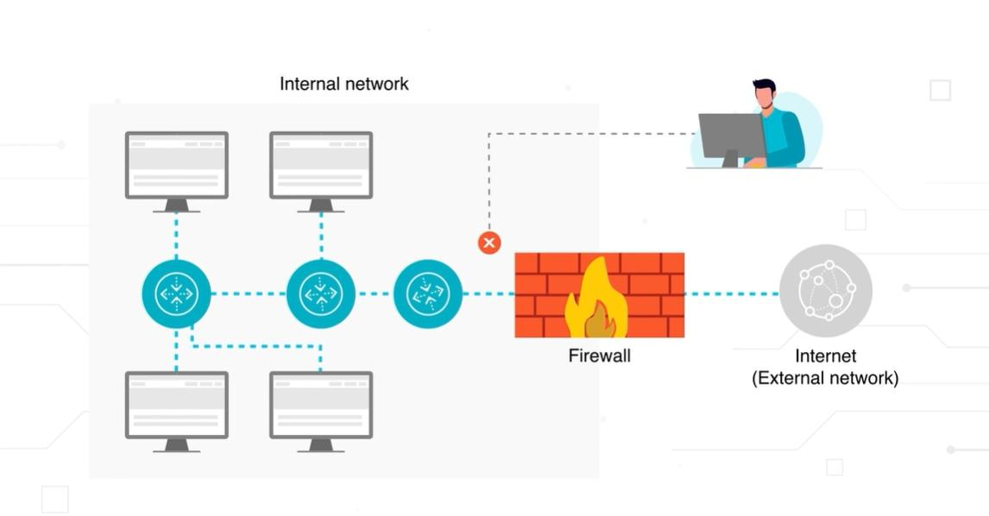
Another problem considered is the Denial of Service (DoS) attack. A DoS attack attempts to make a computer, service, or network resource unavailable to its intended users. Firewall security services can be configured to control access and provide protection against certain types of DoS-related threats.

Figure 2.1-Firewall Architecture

Therefore, this project focuses on implementing and testing a basic firewall configuration that can control network traffic, restrict unauthorized access, and demonstrate basic protection against DoS-related network activity. The project also evaluates the behaviour of the configured rules through simple testing.
3.AIM AND OBJECTIVES

Aim
The main aim of this project is to study and implement a basic firewall system for controlling network traffic and improving network security. The project focuses mainly on restricting unauthorized access and providing basic protection against DoS attacks by using suitable firewall rules.
The project also aims to understand how firewall rules are created, applied and tested in a simple network environment.

Objectives
The major objectives of the project are:

1. To Understand Firewall Concepts
To study the basic concept of a firewall and understand how it controls communication between external and protected networks.

2. To Study Different Firewall Types
To understand the commonly used types of firewalls and their basic working methods.

3. To Control Network Traffic
To learn how firewall rules can be used to allow required network connections and restrict unwanted traffic.

4. To Restrict Unauthorized Access
To configure firewall rules that can prevent connections that are not permitted to access the protected system.

5. To Understand DoS Protection
To study how firewall controls can provide a basic layer of protection against certain DoS-related network activity.

4.FIREWALL BASICS

A firewall is a network security mechanism that controls the flow of traffic between different networks or systems. It examines network connections and applies a set of security rules to determine whether the traffic should be permitted or blocked. In simple terms, a firewall works like a security barrier between a protected system and an external network.
Basic Working of a Firewall
When a network connection reaches a firewall, the firewall checks the information associated with that connection. Depending on the configured rules, the traffic may be allowed to continue or may be blocked. This provides control over both incoming and outgoing network communication.
For example, if a connection matches an allowed rule, the firewall permits the traffic. If the connection matches a blocking rule, the firewall prevents the traffic from reaching the protected system.
Incoming and Outgoing Traffic
Firewall rules can be used to control traffic entering and leaving a system.
Incoming traffic refers to connections coming towards the protected computer or network from another system.
Outgoing traffic refers to connections initiated from the protected computer or network towards another system.
Controlling both types of traffic helps maintain better control over network communication. Firewall Rules
Firewall rules are the basic instructions used to control network traffic. A rule can specify conditions such as the protocol, port, source or destination, and the action to be taken.
The main actions are generally:
- Allow – permits the matching connection.
- Block – prevents the matching connection.

5.TYPES OF FIREWALLS

Firewalls can be classified into different types based on the way they examine and control network traffic. Each type uses a different method to decide whether a connection should be allowed or blocked. The main types commonly discussed are packet-filtering firewalls, stateful inspection firewalls, proxy firewalls, and next-generation firewalls.
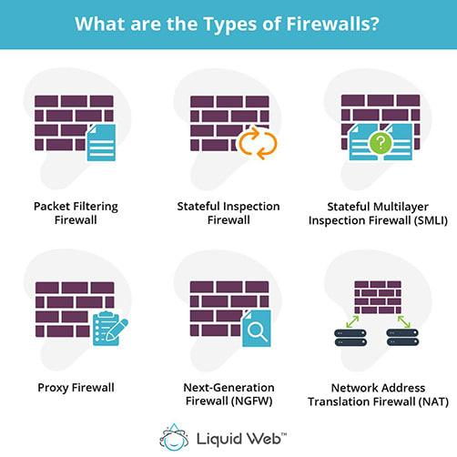

Figure 5.1-Types of Firewalls

This picture shows the different types of firewalls used to protect a corporate network. It includes stateful firewalls, packet-filtering routers, application proxies, and host-based firewalls. The diagram also shows how these firewalls control communication between the Internet and the internal corporate network.

Table 5.2: Comparison of Firewall types
Firewall Type | Basic Function | Example
Packet Filtering | Filters traffic using IP, port and protocol | Basic packet firewall
Stateful Firewall | Checks the state of connections | Windows Firewall
Application Firewall | Controls application-level traffic | Web Application Firewall
Proxy Firewall | Acts as an intermediary between systems | Squid Proxy
Next-Generation Firewall | Provides advanced traffic inspection and security features | Palo Alto NGFW

PACKET FILTERING FIREWALL:
A packet-filtering firewall checks individual network packets and compares their information with predefined rules. It can examine details such as source and destination addresses, ports, and protocols. Based on these conditions, the packet can be allowed or blocked.
This type of firewall is relatively simple and can be useful when basic traffic filtering is required.
STATEFUL FIREWALL:
A stateful firewall keeps track of active network connections. Instead of examining each packet completely independently.
It considers the current state of the connection when making filtering decisions.
APPLICATION FIREWALL:
An application firewall works at the application layer and checks application-level network requests. It acts as an intermediary and helps allow legitimate requests and block unwanted or suspicious requests

PROXY FIREWALL:
A proxy firewall works as an intermediary between the user and the destination service. Instead of allowing a direct connection between the two sides, the proxy receives the request and forwards it after applying the required security checks.
This provides an additional layer between the internal system and the external network.
NEXT-GENERATION FIREWALL:
A next-generation firewall provides more advanced traffic inspection and security capabilities than traditional firewalls. It can combine traditional traffic filtering with additional security functions to identify and control more complex network activity.
These firewalls are generally used in environments where more detailed traffic inspection and security control are required.
Each type of firewall has its own features and method of protecting a network. Packet-filtering firewalls control traffic based on basic information such as IP addresses, ports, and protocols. Stateful inspection firewalls monitor active connections, while proxy firewalls act as intermediaries between users and external networks. Next-generation firewalls provide additional security features to inspect network traffic more deeply. The selection of a firewall depends on the security requirements and size of the network. Overall, firewalls play an important role in controlling network communication, reducing security risks, and protecting systems from unwanted connections.

6.FIREWALL AND RELATED ATTACKS

A firewall helps control network traffic by applying security rules to incoming and outgoing connections. This makes it useful for restricting unwanted traffic and unauthorised access. However, a firewall itself is also a security device that needs proper configuration and protection.
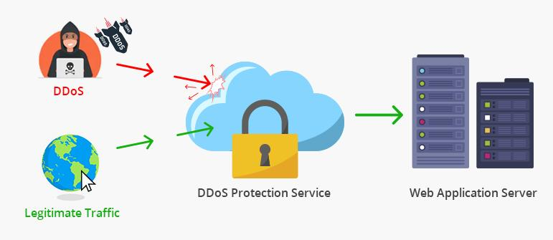

Figure 6.1-Firewall and Related Attacks

The figure shows how DoS/DDoS attack traffic travels from multiple attackers through the Internet towards a protected network. The large amount of unwanted traffic can overload security devices such as the firewall and affect the target system or service.

FIREWALL AND DoS ATTACK:
A Denial of Service (DoS) attack attempts to make a system or network resource unavailable to its intended users. DoS traffic can consume system or firewall resources and affect normal connections. Firewall security features can be used to control traffic and apply limits or protection rules for selected resources.
FIREWALL AND UNAUTHORIZED ACCESS:
A firewall uses access-control rules to decide which connections should be permitted or denied. Properly configured rules can restrict traffic that should not reach protected systems. This helps reduce the possibility of unauthorized users or systems accessing internal network resources.

Table 6.2: Firewall and Related Attacks
Security Item | Type | Basic Effect
Firewall | Security Tool | Controls network traffic
DoS | Makes a service or resource unavailable | Controls and filters suspicious traffic
Unauthorized Access | Attempts to reach protected resources without permission | Blocks connections that violate access rules

The firewall cannot completely stop every type of cyberattack. However, properly configured rules can help control unwanted connections and reduce some network-related risks.
In this project, the firewall is therefore considered the main security tool, while DoS and Unauthorized Network Access are the two related attacks being studied.

7.DoS ATTACK

A Denial of Service (DoS) attack is an attack in which excessive traffic or requests are sent to a system, application, or network resource. This can consume the available resources and make the service slow or unavailable to legitimate users.
A firewall can provide a layer of protection by applying DoS protection rules to selected network traffic. These rules can define conditions and thresholds for traffic and take protective actions when the configured limits are exceeded.
In this project, DoS attacks are studied mainly to understand how firewall rules can help control unwanted traffic and protect important network resources. However, a firewall alone should not be considered complete protection against large-scale DoS attacks.
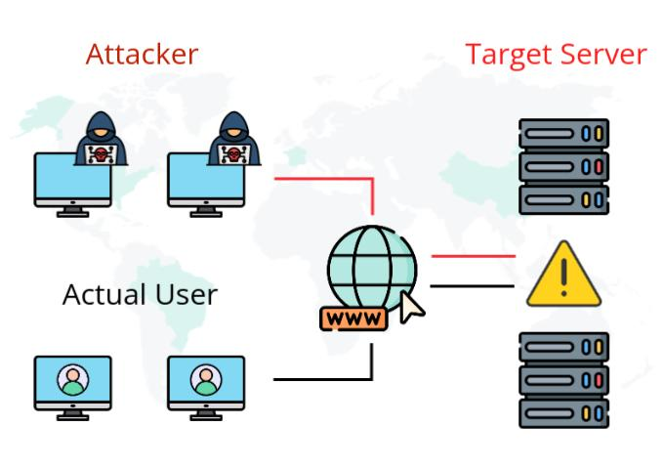
EFFECT OF DoS ATTACK:

Figure 7.1: DoS Attack
A successful DoS attack can make a website, application, server, or network service unavailable to normal users. It may
also consume resources such as bandwidth, connections, processing capacity, or memory. Excessive attack traffic can overload network bandwidth and system resources, making it difficult for legitimate requests to be processed. As resources become exhausted, the service may become slow, unresponsive, or completely unavailable to normal users.
ROLE OF FIREWALL AGAINST DoS:
A firewall can help protect a system from DoS traffic by identifying and filtering network requests according to configured rules. When traffic exceeds a defined threshold, rate-based protection can be used to limit or block excessive requests. This helps reduce the amount of unwanted traffic reaching the protected application or server.
BASIC PREVENTION:
Some basic measures can help reduce the effect of DoS attacks:
- Use properly configured firewall rules.
- Allow only required network connections.
- Block unnecessary ports and services.
- Monitor unusual network traffic.

In conclusion, a Denial of Service (DoS) attack is a serious network security threat that can make a computer, server, or online service unavailable to legitimate users. It can interrupt normal communication and affect the availability of network resources. A properly configured firewall can help reduce certain DoS-related risks by filtering unwanted traffic and applying suitable security rules. However, a firewall alone may not stop every DoS attack, so additional security measures and regular monitoring are also necessary. Therefore, understanding DoS attacks and implementing appropriate security practices are important for maintaining network availability and improving overall security.

8.UNAUTHORIZED ACCESS

Unauthorized access means a person, device, or connection trying to access a system or network without the required permission. If unwanted connections are allowed to reach a protected computer, they may create security risks.
An unauthorized user may try to connect to a restricted service or access a resource that is not meant for them. If such access is successful, important information or network resources may be exposed.
A firewall helps control this type of access by checking incoming network traffic against configured rules. Windows Firewall, for example, can filter traffic using information such as IP addresses, protocols, ports, applications, and services.

HOW UNAUTHORIZED ACCESS HAPPENS:
Unauthorized access can occur through weak or stolen passwords, phishing, software vulnerabilities, and incorrect system configurations. Attackers may use these weaknesses to gain access to accounts or protected network resources.
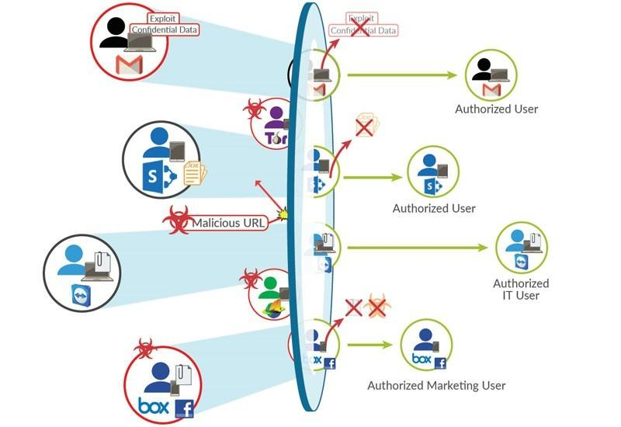
Proper authentication, regular software updates, and firewall access-control rules can help reduce this risk.

Figure 8.1: Unauthorized Network Access

ROLE OF FIREWALL IN PREVENTING UNAUTHORIZED ACCESS:
Firewall rules can be configured to allow or block specific network connections. When a connection does not match an allowed rule or is specifically blocked by a rule, the firewall can prevent that traffic from reaching the system.
For example, an administrator can create an inbound rule to block traffic on a particular port. Similarly, access can be limited to selected programs, IP addresses, or trusted systems. This helps reduce unnecessary access to the computer or network.
Table 8.2: Unauthorized Access
Aspect | Description
Problem | Unpermitted access to a protected system
Possible Source | Unknown or untrusted device
Firewall Action | Allow or block based on rules
Main Protection | Access-control and traffic-filtering rules
Result | Unwanted connections can be restricted

Unauthorized access occurs when a person or device tries to enter a system or network without proper permission. This may happen because of weak passwords, stolen login details, phishing, software vulnerabilities, or incorrect security settings. If unauthorized access is successful, the attacker may reach protected information or network resources.
A firewall helps reduce this risk by checking incoming and outgoing connections according to predefined security rules. It can allow trusted traffic and block connections that are not permitted. Therefore, proper firewall configuration is important for controlling network access and protecting the system from unwanted connections.

9.TOOLS REQUIRED
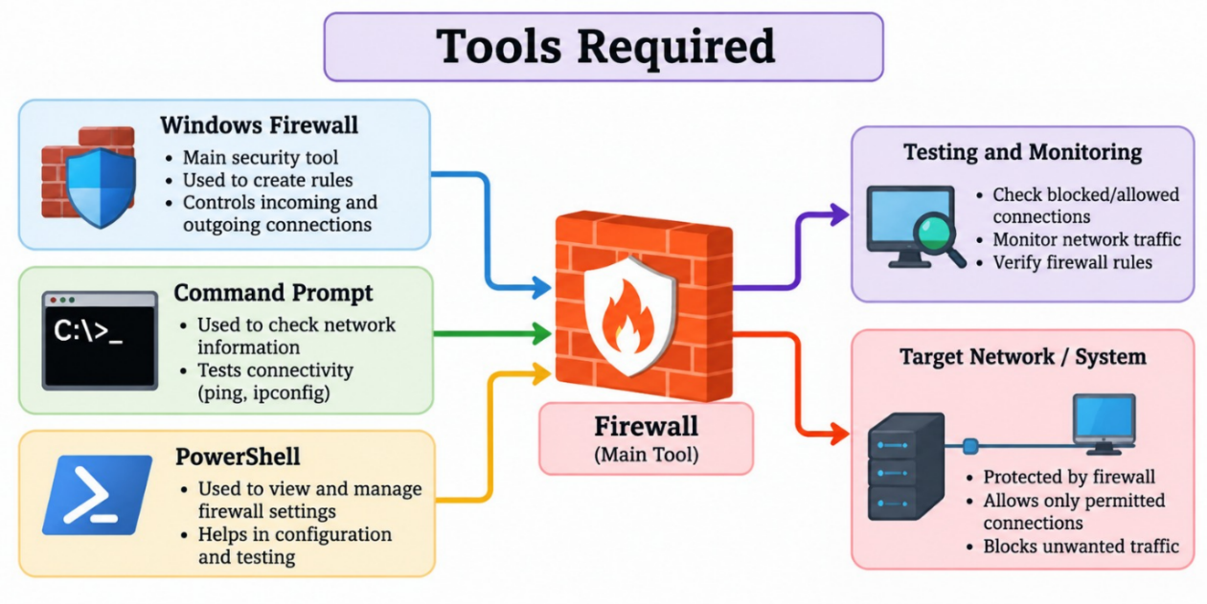
For implementing and testing the firewall, a few basic software tools and system features are required. The tools used in this project help in configuring firewall rules, checking network connections, and observing the effect of the rules.

WINDOWS DEFENDER FIREWALL:

Figure 9.1: Firewall Tools
Windows Defender Firewall is the main security tool used in this project. It provides rules that control incoming and outgoing network traffic. Rules can be configured according to applications, ports, protocols and other network conditions.
WINDOWS COMMAND PROMPT:
Command Prompt can be used to check network information and perform basic connectivity tests. It can also be used with Windows firewall commands for configuration and management.
POWER SHELL:
PowerShell is a Windows command-line tool that can be used to manage Windows Firewall settings and rules. It allows users to create, modify, enable, and manage firewall rules through commands.

10.SYSTEM ARCHITECTURE AND WORKING

The system architecture of the project shows how the external network, firewall, and protected system are connected. The firewall is placed between the external network and the internal system so that network traffic can be checked before reaching the protected system. The firewall uses configured rules to decide whether a connection should be allowed or blocked.

SYSTEM ARCHITECTURE:
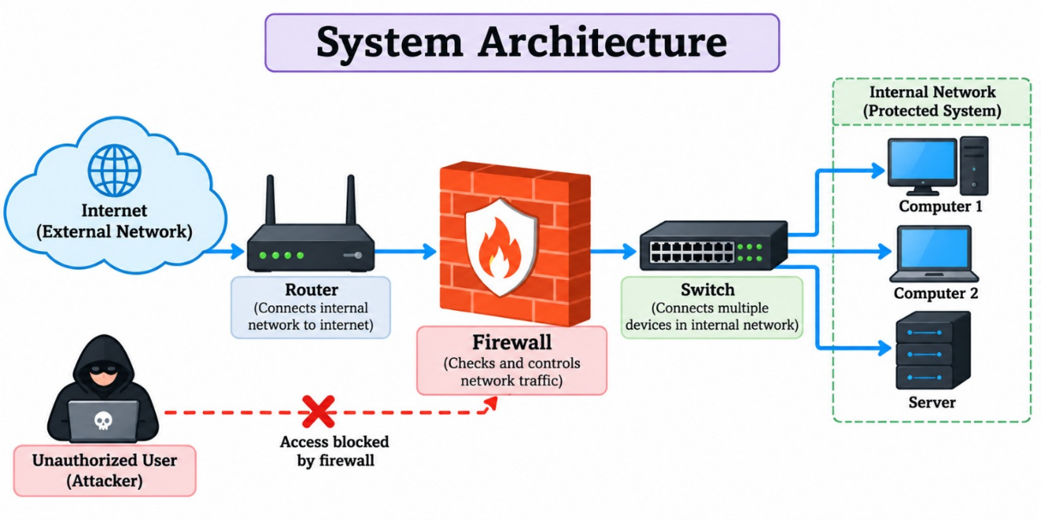
The diagram represents the flow of network traffic from the external network towards the protected system through the firewall. The firewall acts as the control point between the two sides.

Figure 10.1-System Architecture

WORKING OF FIREWALL:
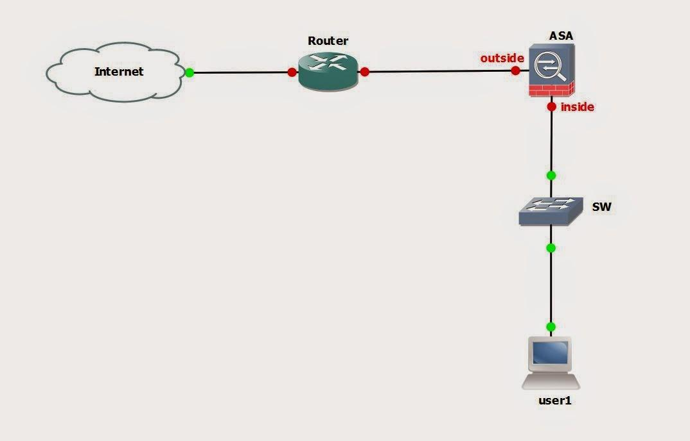

Figure 10.2: Working of Firewall

The figure shows the basic decision-making process of the firewall: Incoming Traffic → Rule Checking → Allow or Block → Protected System.
When a network connection reaches the system, the firewall checks the connection against its configured rules. If the traffic satisfies an allow rule, the connection is permitted. If it matches a block rule, the connection is prevented. Firewall rules can use conditions such as applications, ports, protocols, and IP addresses.
In this project, the working of the firewall is verified by testing the configured rules and observing whether the selected traffic is allowed or blocked. This practical process helps demonstrate how a firewall controls network communication and provides a basic layer of protection against unauthorised access. Regular monitoring and updating of firewall rules are important to maintain effective security.

FIREWALL COMPONENTS:
Table 10.3: Firewall Components
Component | Purpose
External Network | Sends network traffic
Firewall | Filters and controls traffic
Firewall Rules | Define allow or block conditions
Protected System | Receives permitted connections
Administrator
  Configures and manages rules

The system works by placing the firewall between the external network and the protected system. When network traffic reaches the firewall, it checks the traffic against the configured rules. If the traffic is permitted, it is allowed to reach the protected system. If it does not meet the required conditions, the firewall blocks it.
In this way, the firewall provides a control point for network communication and helps restrict unauthorized access and unwanted traffic. The administrator can modify the firewall rules according to the security requirements and test whether the expected traffic is allowed or blocked.
In conclusion, the system architecture explains how the firewall is placed between a computer system and external networks to control network communication. When data enters or leaves the system, the firewall checks the traffic according to the configured security rules and decides whether to allow or block the connection. This process helps restrict unwanted network traffic and reduce the risk of unauthorised access. Testing the configured rules helps verify that the firewall works as expected. Thus, the system architecture and working process provide a clear understanding of how a firewall helps protect a computer system and improves network security.

11.IMPLEMENTATION PROCEDURE

The implementation procedure explains how the firewall is configured and tested in the project. The process starts with checking the existing firewall settings and then creating suitable rules for controlling network traffic. The configured rules are finally tested to verify their behaviour.
First, the firewall settings are checked to understand the current security configuration of the system. In a Windows system, Windows Defender Firewall settings can be opened through the Control Panel or Windows Security settings. The existing firewall status and available network profiles are reviewed before making any changes.
Next, suitable firewall rules are created based on the requirements of the project. These rules may control incoming or outgoing traffic and can be configured using details such as port numbers, protocols, and connection permissions. Each rule should have a clear purpose so that necessary communication is allowed and unwanted connections are restricted.
After creating the rules, the firewall configuration is checked to ensure that the settings have been applied correctly. The rules are then tested using permitted and restricted connections. The results are observed to determine whether the firewall allows or blocks the selected traffic as expected. If any rule does not work as intended, its settings are reviewed and corrected.
Finally, the testing results are recorded for project documentation. This procedure provides a practical understanding of firewall configuration and demonstrates how security rules can be used to control network traffic. Care should be taken while modifying firewall settings because incorrect rules may interrupt normal network communication.

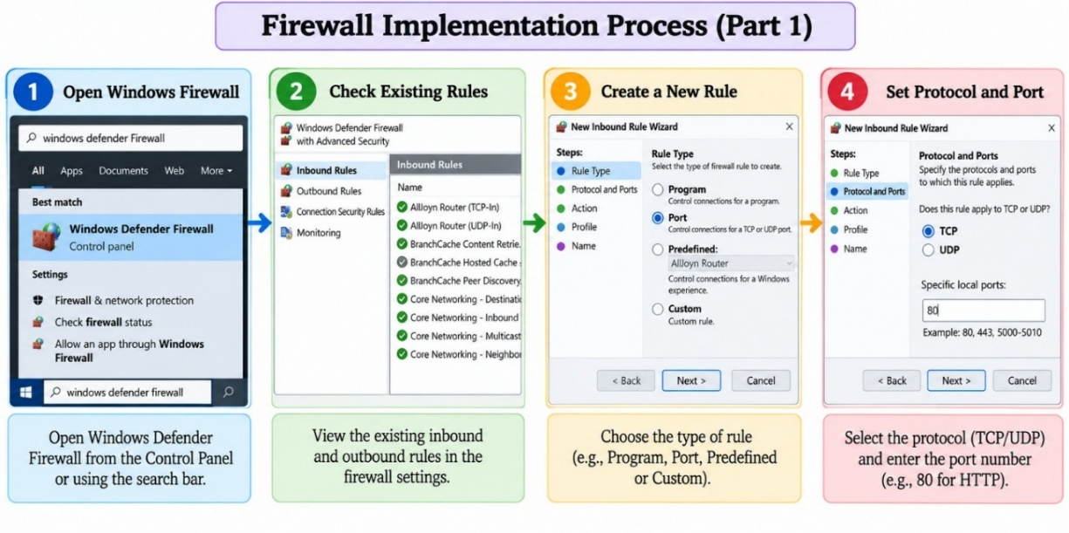
Figure 11.1-Firewall Implementation Process
OPEN WINDOWS FIREWALL:
First, open Windows Firewall with Advanced Security to access the detailed firewall configuration options and rules.
CHECK EXISTING RULES:
After opening the firewall console, check the existing Inbound Rules and Outbound Rules. These rules show how incoming and outgoing network traffic is currently controlled. CREATE A NEW RULE:
To control specific network traffic, select Inbound Rules and choose Action → New Rule. The New Rule Wizard provides options for creating the required firewall rule.
SET PROTOCOL AND PORT:
Select the required protocol, such as TCP or UDP, and specify the appropriate port number for the rule. This allows the firewall to control traffic associated with the selected protocol and port.
The first step is to open the Windows Firewall and access its advanced security settings. The existing inbound and outbound rules are then checked to understand the current traffic-control settings. After that, a new firewall rule is created using the New Rule option. Finally, the required protocol, such as TCP or UDP, and the appropriate port number are selected for the new rule.
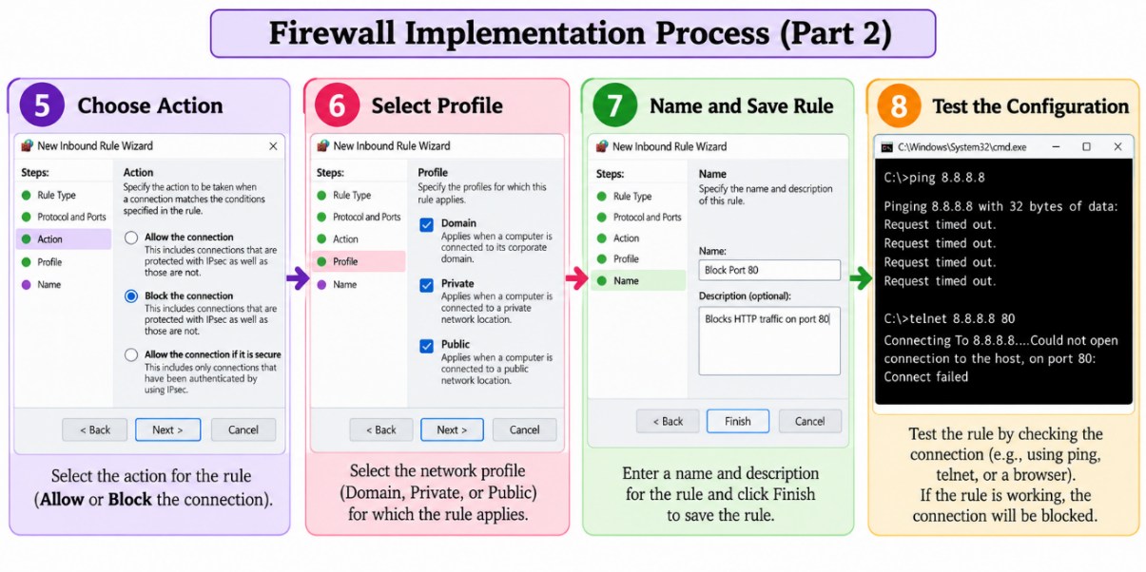
Figure 11.2: Firewall Implementation Process

CHOOSE ACTION:
Select whether the firewall should allow or block the specified network connection.
SELECT PROFILE:
Choose the network profile where the rule should apply, such as Domain, Private, or Public.
NAME AND SAVE RULE:
Enter a suitable name and description for the rule and click Finish to save it.
TEST THE CONFIGURATION:
Test the configured rule using a suitable network connection to verify whether the traffic is correctly allowed or blocked.
By following the above implementation steps, the firewall can be configured and tested systematically. Each step helps ensure that the security rules are created correctly and work according to the project requirements. Testing the rules makes it possible to verify whether the selected network traffic is allowed or blocked as expected. The results are recorded for further analysis and documentation. Thus, the implementation procedure provides practical knowledge of firewall configuration and demonstrates how firewall rules help control network traffic and reduce the risk of unauthorised connections.

Table 11.3: Firewall Implementation steps
Step | Activity
1 | Open Windows Defender Firewall
2 | Check existing rules
3 | Create a new rule
4 | Select protocol or port
5 | Choose Action
6 | Select profile
7 | Name and Save Rule
8 | Test the Configuration

The firewall implementation process starts by opening Windows Defender Firewall and checking the existing rules. A new rule is then created by selecting the required protocol or port. Next, the appropriate action, such as Allow or Block, and the required network profile are selected. The rule is given a suitable name and saved. Finally, the configuration is tested to verify that the firewall is correctly controlling the specified network traffic.
In conclusion, the implementation procedure helps to understand the practical process of configuring and testing a firewall. By checking the existing settings, creating suitable firewall rules, and testing network connections, the system can be configured according to the project requirements. The testing process verifies whether the firewall allows permitted traffic and blocks restricted connections as expected. It also helps identify configuration errors that may affect normal network communication. Overall, the implementation procedure demonstrates the importance of proper firewall configuration, regular monitoring, and careful testing in improving network security and reducing the risk of unauthorised access.

12.FIREWALL RULES AND TESTING

Firewall rules define which network traffic should be allowed or blocked. Windows Firewall can filter traffic using conditions such as applications, protocols, IP addresses, and port numbers. These rules help control network communication and protect the system from unwanted connections.
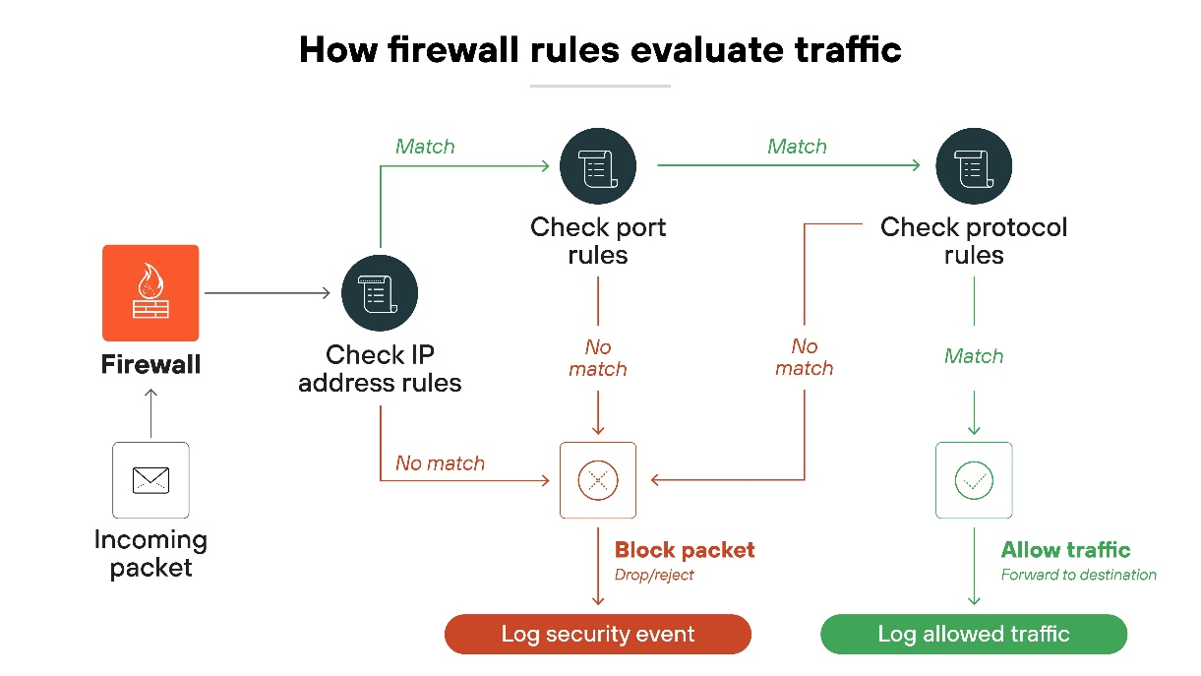
FIREWALL RULE CONFIGURATION:

Figure 12.1: Firewall Rule Configuration
The required firewall rule is created by selecting the appropriate inbound or outbound rule. The protocol, port, action, network profile, and other required conditions are configured according to the purpose of the rule. Finally, the rule is given a suitable name and saved.
After configuration, the rule should be tested to confirm that it behaves as expected. If the required connection is blocked unexpectedly or restricted traffic is still permitted, the rule settings should be reviewed. Proper configuration and testing help avoid errors and maintain normal network communication. Therefore, firewall rules should be created carefully and reviewed regularly to support effective network security.

TESTING RESULTS:
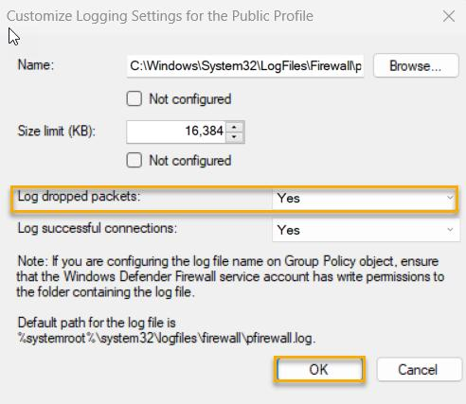
After creating a firewall rule, it should be tested to verify whether it is working as expected. Testing can be performed by checking whether the required connection is allowed or blocked. Windows Firewall can also record successful connections and dropped packets in its log files, which helps in checking the behaviour of the configured rules.

Figure 12.2: Firewall Testing Results
The testing process confirms whether the configured firewall rules are correctly controlling network traffic. If a blocked connection appears as a dropped packet in the firewall log, it indicates that the firewall rule is working as intended. Successful connections can also be recorded for verification.

13.RESULTS AND DISCUSSION

The firewall was configured with rules to control incoming and outgoing network traffic. During testing, the configured rules were checked to verify whether permitted connections were allowed and unwanted connections were blocked. Windows Firewall supports filtering traffic based on factors such as IP addresses, protocols, ports, applications, and services.
RESULTS:
The testing showed that the firewall was able to apply the configured rules correctly. Allowed traffic could communicate normally, while traffic matching a blocking rule was prevented. Firewall logs can also be used to observe blocked or allowed network activity.
DISCUSSION:
The results demonstrate that properly configured firewall rules can help control network communication and reduce unwanted access to protected systems. The firewall acts as a control point between the external network and the protected system. However, the effectiveness of the firewall depends on having appropriate and correctly configured rules
Table 13.1: Firewall Testing Results
Test | Expected Result | Observed Result | Status
Allowed Connection | Traffic should be allowed | Connection successful | Pass
Blocked Connection | Traffic should be blocked | Connection denied | Pass
Firewall Log |  | Entry observed | Pass
  Activity should be recorded
Rule verification | Rule should work correctly | Rule worked as configured | Pass

14.ADVANTAGES AND LIMITATIONS

Firewalls help maintain network security by examining incoming and outgoing traffic and applying suitable security rules. They allow necessary connections while blocking traffic that does not meet the specified conditions. Regularly checking firewall settings and updating security rules helps improve protection. However, firewalls should be used along with other security measures to provide better protection against network threats.
Table 14.1: Advantages and Limitations

Advantages | Limitations
Controls unwanted network traffic | Requires proper configuration
Helps restrict unauthorized access | Cannot provide complete security alone
Supports rule-based traffic control | May block legitimate traffic
Provides logging and monitoring | Requires regular management

Advantages: A firewall improves network security by monitoring incoming and outgoing traffic. It helps prevent unwanted connections, controls access to network resources, and allows communication according to predefined security rules.
Limitations: A firewall alone cannot provide complete protection against all security threats. Incorrect configuration may interrupt normal network communication, so regular monitoring and additional security measures are necessary.
15.SAFETY AND FUTURE SCOPE

SAFETY MEASURES:
Firewall safety depends on proper configuration and regular maintenance. Only necessary network traffic should be allowed, while unwanted connections should be restricted. Administrators should check firewall settings from time to time and remove rules that are no longer needed. Keeping the firewall updated and reviewing its logs can help detect unusual network activity. These steps help maintain network security and reduce the risk of unauthorized access.
In addition, strong security practices should be followed while managing firewall settings. Changes to firewall rules should be made carefully to avoid interrupting normal network communication. Access to firewall configuration should be limited to authorized administrators. Regular monitoring helps identify unexpected changes or suspicious traffic. Important firewall settings should also be documented so that they can be reviewed and maintained easily. Following these safety measures helps improve the reliability of the firewall and supports better protection of the network.
FUTURE SCOPE:
The firewall system can be improved in the future by adding more advanced monitoring and management features. Firewall logs can be analyzed to identify unusual traffic patterns and support better security monitoring. More detailed rules can also be created based on applications, ports, protocols, and IP addresses. Future implementations can also combine firewall protection with other network-security mechanisms to provide a stronger and more comprehensive security solution. This can make the system more suitable for larger and more complex network environments.

16.CONCLUSION

The Firewall Implementation project demonstrates how a firewall can be used to control and filter network traffic between a system and external networks. Firewall rules can be configured to allow or block traffic based on factors such as IP addresses, ports, protocols, applications, and services.
Through this project, the process of creating firewall rules, configuring their conditions, applying allow or block actions, and testing the configured rules was studied. The testing process helps verify whether the firewall is correctly controlling the required network connections.
Overall, the project shows that a firewall provides an important layer of network security by reducing the attack surface and restricting unauthorized network traffic. However, firewall configuration must be properly managed and should be used as part of a broader, layered security approach.
The project provides a basic understanding of firewall configuration, rule management, and network traffic filtering. It highlights how a firewall helps reduce risks related to DoS attacks and unauthorised access by controlling unwanted network connections.
Regular monitoring, proper configuration, and timely updates help maintain firewall effectiveness. Although a firewall cannot prevent every cyberattack, it provides an important layer of protection when combined with other security measures. Overall, the project explains the practical importance of firewalls in improving network security.

17.REFERENCES

- Scarfone, K. and Hoffman, P. (2009). Guidelines on Firewalls and Firewall Policy. NIST Special Publication 800-41 Revision 1. National Institute of Standards and Technology. Available at: https://csrc.nist.gov/pubs/sp/800/41/r1/final
- Microsoft. Firewall and Network Protection in the Windows Security App. Microsoft Support. Available at: https://support.microsoft.com/en-us/windows/security/windows-security/firewall-and-network-protection-in-the-windows-security-app
- Microsoft. Configure Windows Firewall Logging. Microsoft Learn. Available at: https://learn.microsoft.com/en-us/windows/security/operating-system-security/network-security/windows-firewall/configure-logging
- Microsoft. Guidance for Troubleshooting Windows Firewall with Advanced Security. Microsoft Learn. Available at: https://learn.microsoft.com/en-us/troubleshoot/windows-server/networking/troubleshoot-windows-firewall-with-advanced-security-guidance
- Cloudflare. What Is a Distributed Denial-of-Service (DDoS) Attack? Available at: https://www.cloudflare.com/learning/ddos/what-is-a-ddos-attack/
- Cloudflare. DDoS Attack Coverage. Cloudflare Documentation. Available at: https://developers.cloudflare.com/ddos-protection/about/attack-coverage/
- OWASP Foundation. Authorization Cheat Sheet. OWASP Cheat Sheet Series. Available at: https://cheatsheetseries.owasp.org/cheatsheets/Authorization_Cheat_Sheet.html
- OWASP Foundation. Implement Access Control. OWASP Top 10 Proactive Controls. Available at: https://top10proactive.owasp.org/the-top-10/c1-accesscontrol/

